## **How to scan for setups**

One of the most important parts to finding winning setups is looking for the strongest stocks in the markets  
  
These are usually in sectors with a strong theme coming out of big weekly bases  
  
Strong names with average setups are better than weaker names with amazing setups.   
  
The setup is not as important as the name but it does serve a purpose in providing a great entry and risk reward opportunity.   
  
When scanning for stocks you want to first figure out what the trend of the overall market is.  
  
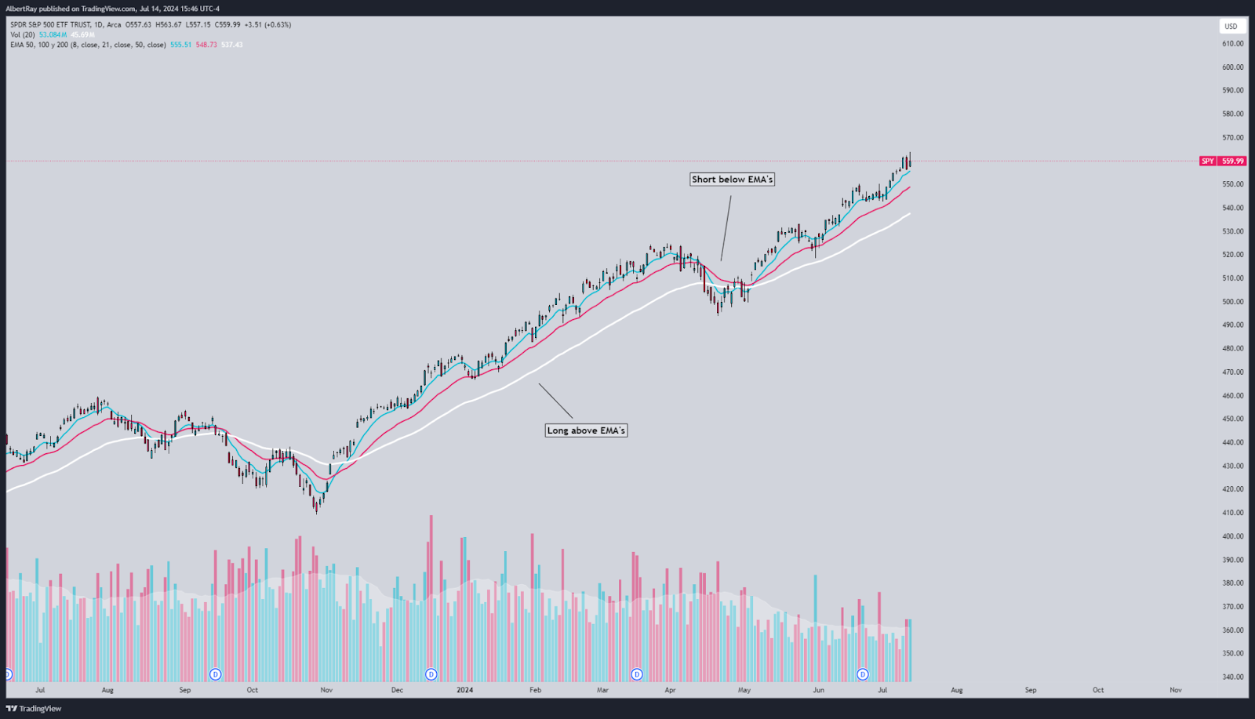  
  
If the markets are above the 8,21 and 50 EMA’s then we know the market is in a strong bullish uptrend  
  
If the markets are below the 8,21, 50 EMA’s then we know the markets are weaker and we should either look for weak names to short or de risk entirely  
  
Knowing and applying these simple rules, keep you from trading against the market and makes your trading a lot more simple. The goal of breakouts is to catch momentum.. Think about how hard it will be to catch momentum when trying to trade against the overall stock market--it's not impossible but it's a lot harder. Never trade against the trend, and always use the moving averages as guide to how the market is holding up  
  
Above the 8 EMA= Lots of momentum and breakouts should be following through   
  
Below 8 EMA/ Above 21= Strong trend still intact but market need time to digest and rebuild  
  
Below the 21 EMA/ Above the 50= Trend still intact but buyers need to step up(These are better dip buying conditions as the 50 EMA usually serves as a great reversal spot).   
  
Under all the moving averages = Look for short setups to form and de risk from longs until a reclaim of the moving averages.   
  
Now that we know what trend the market is in we can move on to finding the strongest sectors in the market  
  
The most important factors to our scan are going to be strong stocks and lots of volume.  
  
  
The simplest way to scan for strong sectors is to use a heatmap.   
  
I like to use FinViz as its a free website and gives you all the information you need in a clean and simple layout  
  
**Step 1.**  
  
-Head over to https://www.tradingview.com/  
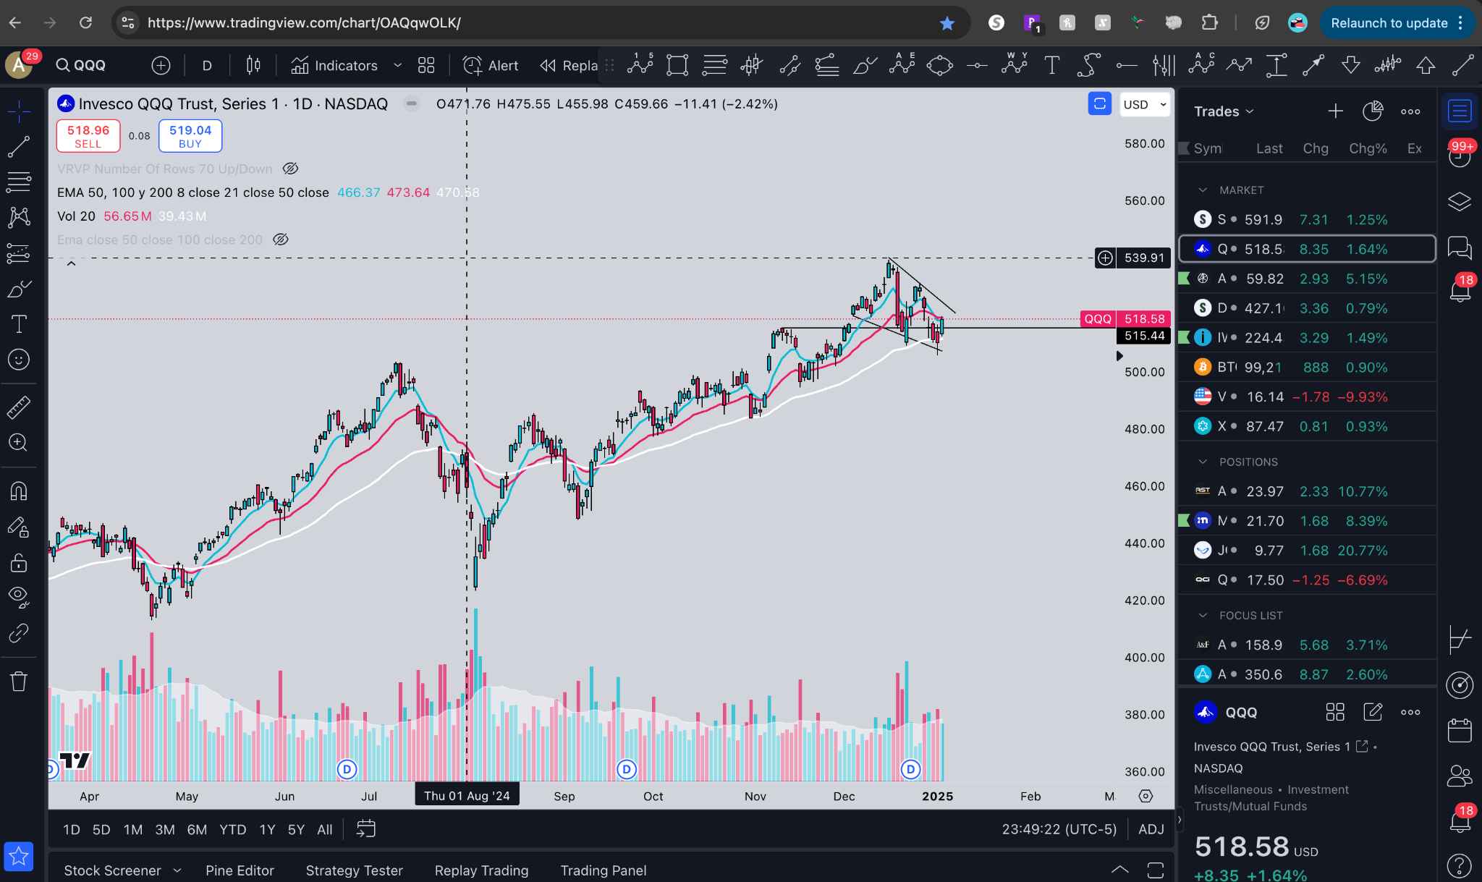  
**Step 2.**  
  
Click the screener tab at the bottom right  
  
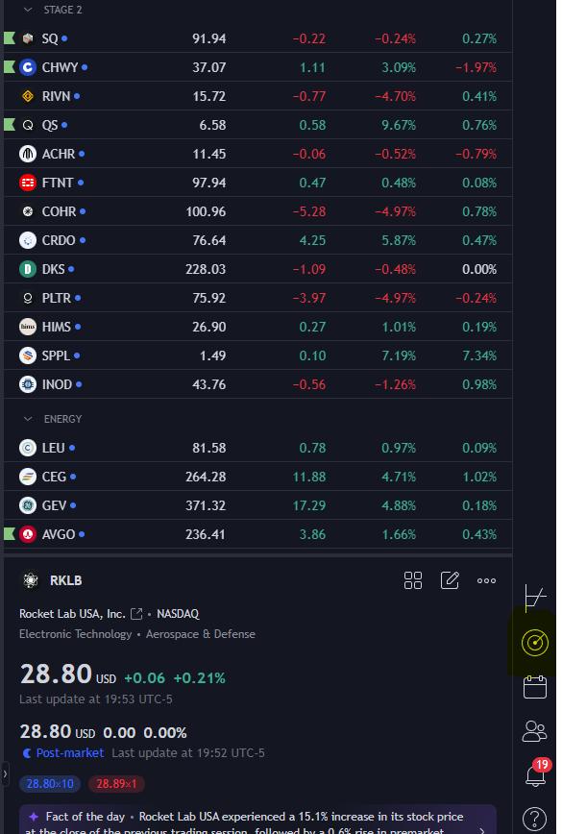

**Step 3.** 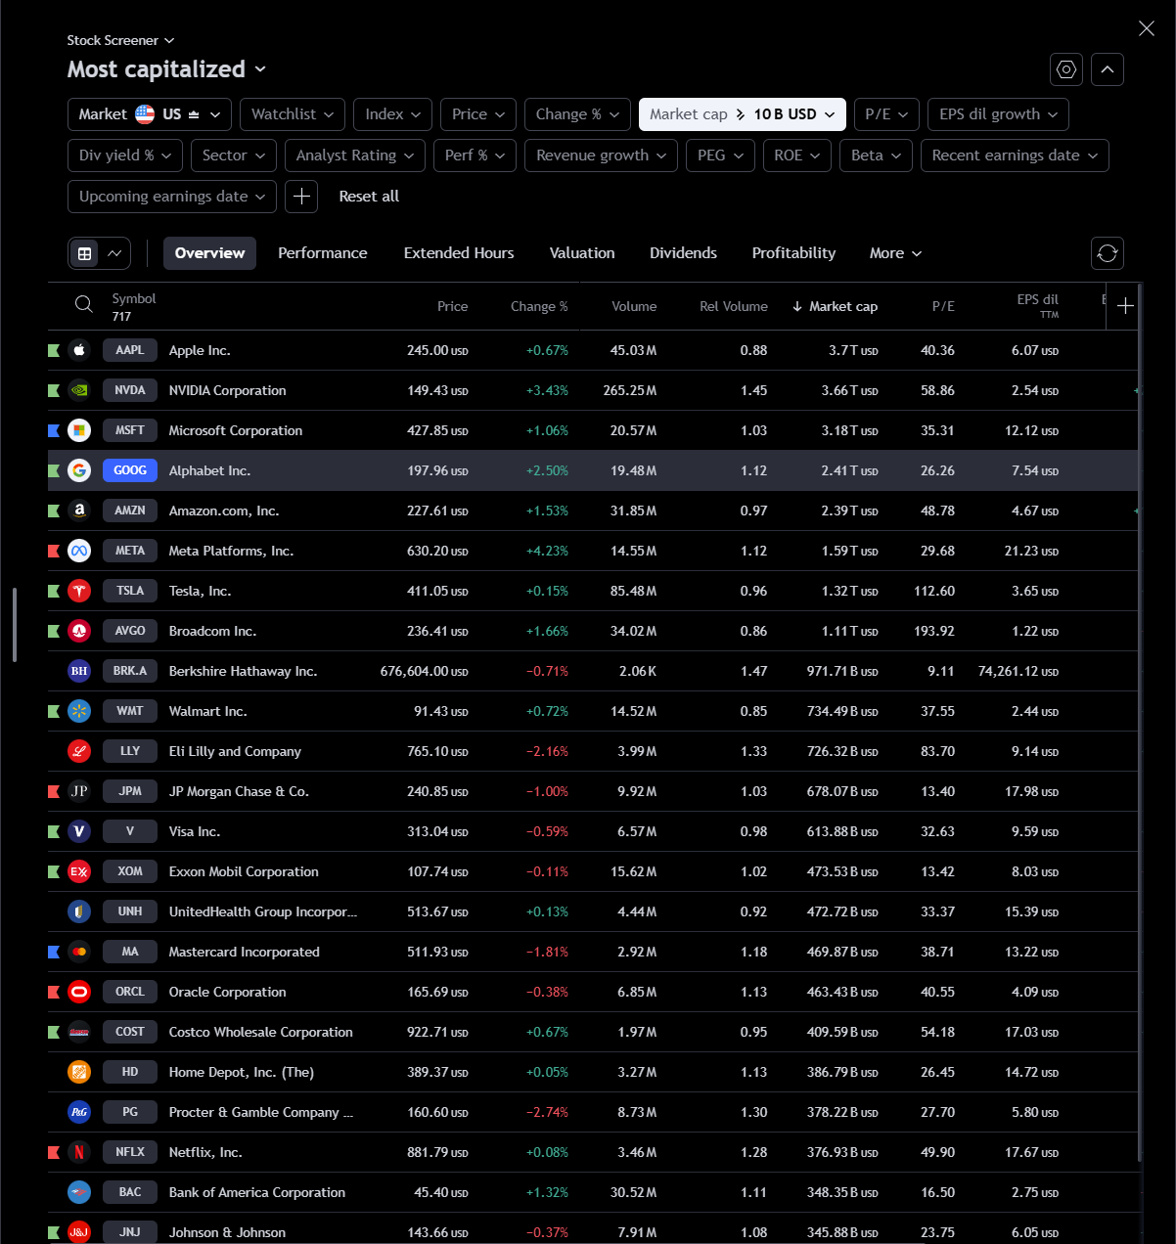  
  
A page will pop with a bunch of stocks to look through  
  
Our goal is to narrow this down and look for stocks that are leading the markets higher on high volume  
  
  
  
**Step 4.  
  
To narrow it down use these parameters  
  
Price: over $3  
Change: over 0.01%  
Market cap: over 2b  
EMA 8: set to below price**  
**EMA 21: set to below price  
EMA 50: set to below price  
  
Rel volume: over 1**  
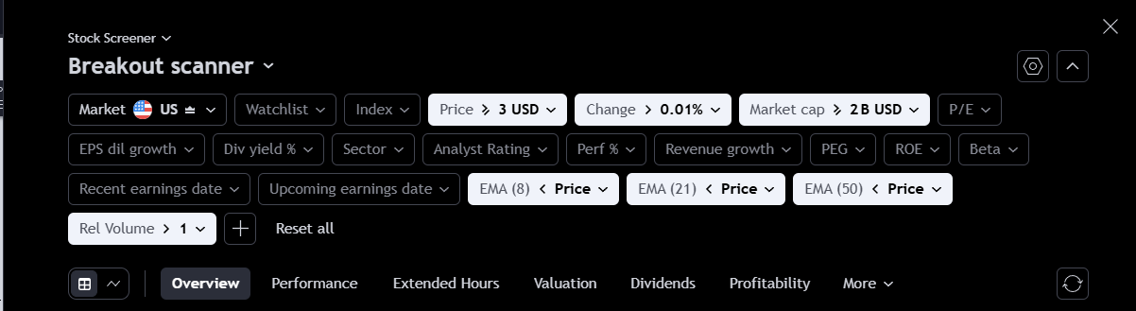  
  
Now make sure to change this tab to   
  
Line   
Then candles  
Then 6 month timeframe  
  
  
Now you should see charts like this on your scan  
  
What this does is basically shows us the most liquid stocks, that are trading with high volume, leading the markets higher and holding in a very strong trend  
  
From here we narrowed down our search from 7000+ stocks to only 200  
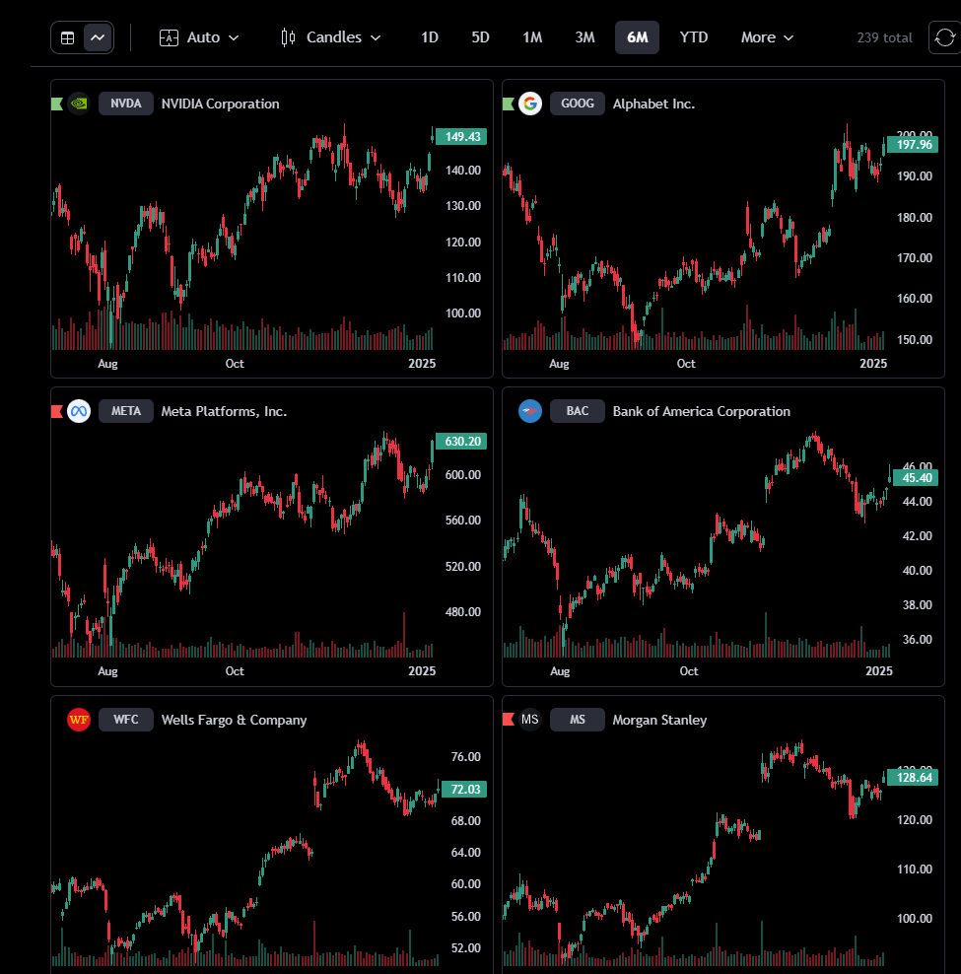  
  
**Step 5.**   
  
Now you have to start manually scanning these names  
  
Here's what we look for to add a stock to our watchlist:  
  
1. Big base setting up near the highs  
2. Compression in the stock via a chart pattern  
3. Breakout that just occurred  
  
Ideally we are looking for stocks that have not broken out yet, but if a stock is just now starting to breakout you can add it to your list for relative strength and look for pullbacks and patterns to develop on it.  
  
Once you scan through and find big bases that are setting up to breakout  
  
create your watchlist and add all of the names you found  
  
Here are some examples of names i chose:  
  
**$GOOG**  
  
Setting up in a big daily pennant at the all time highs  
  
Strong volume patterns   
  
Big weekly breakout  
  
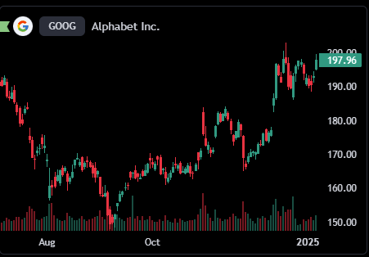  
  
**$META**  
  
Big daily breakout and retest   
  
Now setting up in a tight range  
Looks ready for an all time high breakout  
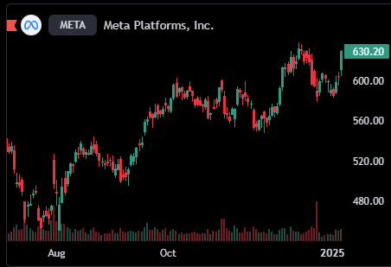  
  
$BSX  
  
Setting up in a tight daily base above the moving averages  
  
Accumulation volume patterns setup  
  
Looks ready for continuation  
  
  
You can now add these names to a “focus list”  
  
  
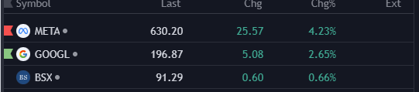  
  
Now you have a list of some of the strongest names in the market that are leading things higher to trade when they breakout  
  
Pick you trigger levels   
  
Now all thats left do is execute